Chapter 11: HML5 Supports Multimedia!!!!

Does it really? That’s surprising!!! I never knew!?!?!?!??! Until now that is ;p

Contents

Video Tags!!! 1

Popular video formats 1

The Video Tag 1

Video Tag Attributes 2

So you want to add subtitles 2

Best Practice 3

Audio Tags!!!!! 3

Popular Audio Formats 3

The Audio Tag 4

Audio Tag Attributes 4

Best Practice 4

The HTMLMediaElement 5

HTMLMediaElement Functions 5

HTMLMediaElement Properties 6

HTMLMediaElement Events 8

# Video Tags!!!

If you were unaware, these are great things! They make your life much easier!! So much easier that I’d say that your life becomes 10x easier!! No more flash or shockwave or any other garbage frameworks that forced us to write code to display videos. Who does that? Not us, anymore!! We write HTML5 code now!!! And this is how!

## Popular video formats

There are formats that are the quarterbacks and prom queens of videos. They reign supreme as the most accepted of their kind. Everyone likes them or is at least forced (on some level) to like them. Anyway, here they are, you should probably know them too!

* Ogg/Theora (.ogv extension): Royalty free with no patent
* WebM/VP8 (.webm extension): Googles format uses BSD open-source license
* MPEG-4/H.264 (.mp4 extension): Patented

**MPEG-4/H.264 is the most popular of them all!!!!!!**

## The Video Tag

The whole point of this section! This is what you’ve been reading for! Don’t hold your breath any longer!!! Because I’ve got what you’ve been hankering. The food that tastes the best! The story that keeps your mind racing! The video tag that plays video on the web!!!!!!

Yeah, whatever. You were probably expecting a lot from this section after that intro. Well sorry all you get is a link. If you click the link, you might get more of what you were expecting…………

<http://www.w3schools.com/html/tryit.asp?filename=tryhtml5_video>

## Video Tag Attributes

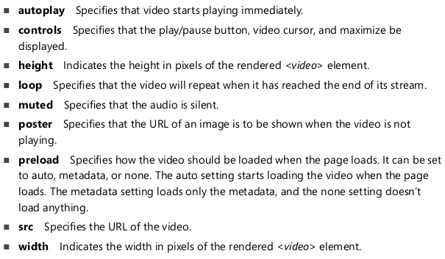

## So you want to add subtitles

Well you can!!! The format used is called WebVTT or Web Video Text Tracks. Here is how it works:

* The file starts with a declaration of WEBVTT FILE
* Skip a line
* Define a cue which is composed of:
  + A timespan on the first line
  + The caption on the next line or lines
* There is a line separator between each cue

Here is an example of the format of a WebVTT file

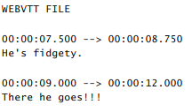

Here is an example of how you reference a WebVTT file in your video tag.

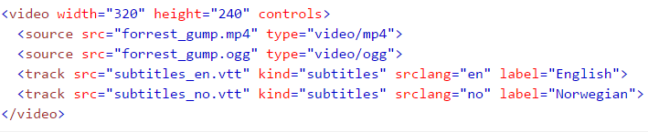

## Best Practice

* Provide the same video in different video formats. You can do this by specifying multiple sources. The browser will decide which to play by checking to see if they are supported in the order the source is specified.

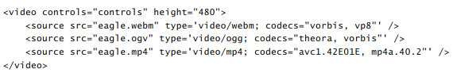

In the example above, the browser will see if it can play .webm. If it can’t, then it will proceed to try to play the .ogv file. If it can’t, then it will try to play the .mp4 file.

* Include a Mime type and Codec in the source attribute. This helps the browser determine what is required to play the video.



* Provide a default message to the user if their browser doesn’t support HTML5.

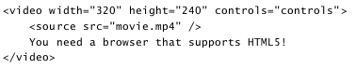

# Audio Tags!!!!!

I bet you thought that the video element was cool! Well, your right! It is quite awesome! But is it as awesome as the audio element?!?!? Only continuing to read further will allow you to find out!! So what are you waiting for??? Push forward and discover a whole new world of sound on the web with the audio element!!!!

## Popular Audio Formats

People have trouble deciding what the best of anything is... So there’s going to be a bunch of popular audio formats... I know, I know... It’s troubling to think that people can’t decide on something so simple.. Well maybe it’s not so simple!! Did you ever consider that??!?1 You did?!?1 Well, okay then. These are the most popular audio formats.

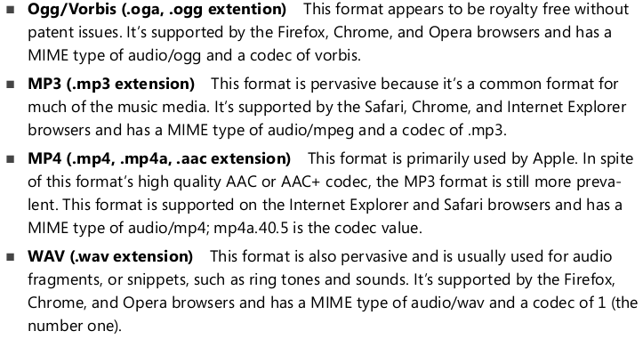

## The Audio Tag

Yup, it’s pretty magical. Take a look at this link to see the implementation!

<http://www.w3schools.com/tags/tryit.asp?filename=tryhtml5_audio>

## Audio Tag Attributes

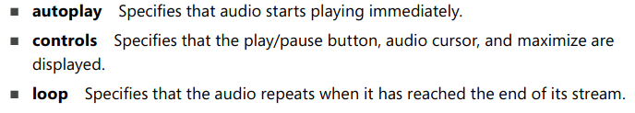

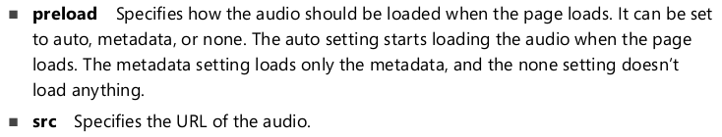

## Best Practice

* Provide the same audio in different audio formats. You can do this by specifying multiple sources. The browser will decide which to play by checking to see if they are supported in the order the source is specified.

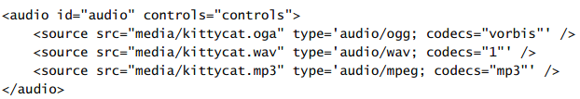

In the example above, the browser will see if it can play .oga. If it can’t, then it will proceed to try to play the .wav file. If it can’t, then it will try to play the .mp3 file.

* Include a mime type and codec to play the audio file. This helps the browser determine what file to play based on the codecs it has installed.



* Provide a default message to the user if their browser doesn’t support HTML5.

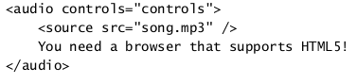

# The HTMLMediaElement

The first thing you need to know is that the Audio and Video tags are children of HTMLMediaElement. Now that you know that your world is about to change. Because I am going to tell you now that the HTMLMediaElement has its own functions, its own properties and EVENTS!! So basically you can do whatever the hell you want with video and audio using built-in functions, properties and events!!! Pretty cool, right? You’d be right to think so, because it is quite cool! Anyways, here are the functions, properties and events that you can have fun with!!!

## HTMLMediaElement Functions

You can pull a video or audio element out of the DOM using JavaScript and call any of these methods on it!

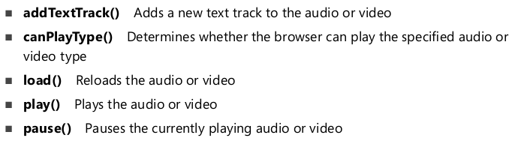

## HTMLMediaElement Properties

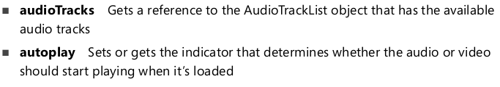

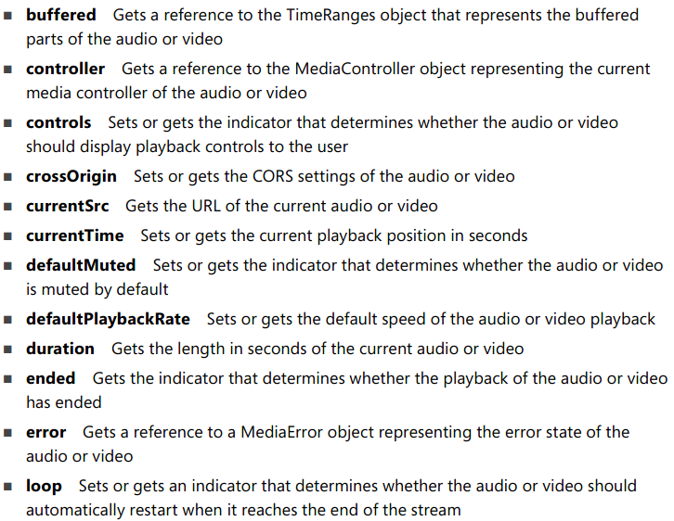

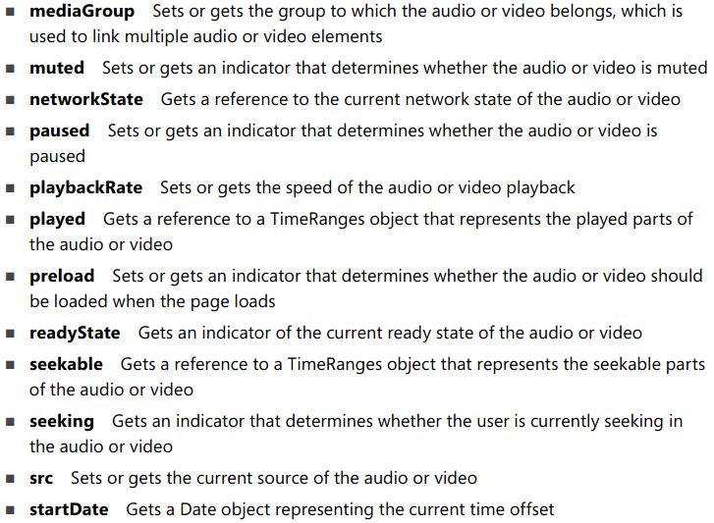

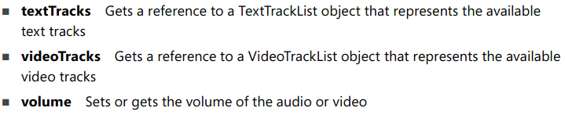

## HTMLMediaElement Events

